**“THE MEGA BAZAAR”**

A Project Report submitted in partial fulfilment of the requirement for the award of degree

# Bachelor of Computer Applications

## (Cloud Technology and Information Security) 2022-2025

|  |  |
| --- | --- |
| **Supervised By** | **Submitted**  **By** |
| Mrs Mamta Gupta | Nikita |
| Assistant Professor | BCA-CTIS-VI |

Sem

Department of Computer Applications 220187558



## Department of Computer Applications

### PANIPAT INSTITUTE OF ENGINEERING & TECHNOLOGY

KUKRUKSHETRA UNIVERSITY, KURUKSHETRA

2022-25

# INDEX

Acknowledgement……………………………………………………I

Certificate from the Student………………………………………… II

Certificate from the Department……………………………………...III

Certificate from Company ……………………………………….…. IV

List of figures……………………………………………………. …..V

## Chapter 1: Company Profile 6

1.1 About Company ..................................................................................................... 7

1.2 Product Management……………………………………………………………,,.7

## Chapter 2: Introduction 9

2.1 Introduction ..................................................................................................... 10

2.2 What is megabazaar… ......................................... 10

2.3 Background of Study… ....................................................................................10

2.4 Objective of project ........................................................................................,10

2.5 Scope of project ........................................................................................ 11

## Chapter 3: Feasibility Study 12

3.1 Overview ..................................................................................................... 13

3.2 Operational Feasibility

3.3 Technical Feasibility .................................................................................... 13

3.4 Economic Feasibility.................................................................................... 14

3.5 Behavioral Feasibility ................................................................................... 14

## Chapter 4: Software Development Life Cycle 15

4.1 Software Development Life Cycle…............................................................ 16

4.2 SDLC Phase………………………………………………………………….16

## Chapter 5: Requirement Gathering /Analysis 17

5.1 Requirement Analysis… .................................................................................. ...18

5.2 Software and Hardware Requirements ............................................................... 18

5.2.1 Software Requirements .....................................................................................18

5.2.2 Hardware Requirements…............................................................................... 18

5.3 User Requirements .............................................................................................. 19

5.4 Functional Requirements…...................................................................................19

5.5 Non functional Requirements ............................................................................. 19

5.6 Business Requirements… .................................................................................. .20

## Chapter 6: System Design 21

6.1 ER Diagram .................................................................................................................... 22

6.2 DFD……………………………………………………………………………………..22

6.2.1 0 Level DFD………………………. 6.2.2 1 Level DFD……………………………..22

## Chapter 7 : Testing 26

7.1 Introduction ..................................................................................................................... 27

7.1.1 Objective......................................................................................................... 27

7.2 Types of Testing ....................................................................................................... 27

7.3 Testing Strategy ........................................................................................................ 28

## Chapter 8 : Implementation 29

8.1 Software Used ..................................................................................................................30

8.2 Hardware Specification ....................................................................................................30

8.3 Platform ...........................................................................................................................30

8.4 Technologies Used .................................................................................................. 30

## Chapter 9: Snapshots 31

9.1 Form Design .................................................................................................................... 32

9.1.1 Admin Panel .................................................................................... 32

9.1.2 Login Page ..................................................................................... 32

9.1.3 Home Page ...................................................................................... 33

9.1.4 About us Page .................................................................................. 33

## Chapter 10: Maintenance 36

10.1 Software Maintenance .......................................................................................... 37

10.1.1 Software Maintenance process ........................................................... 37

10.1.2 Maintenance Activities… .................................................................. 37 10.1.3 Difficulties of Maintenance................................................................ 37

## Chapter 11: Conclusion and Future Work 39

11.1 Conclusion ......................................................................................................... 39

11.2 Limitations......................................................................................................... 39

11.3 Future Plans… ................................................................................................................39

**Bibliography** 41

# Acknowledgement

A successful completion of this project is attributed to the great and indispensable help received from different people.

I will always be grateful and thankful to Head of Department **Dr. Dinesh Verma** and Project Mentor **Mrs.Mamta Gupta** for giving me the opportunity to learn the different aspects of designing and implementing this system. It would never be possible for me to design this system without your continuous assistance and guidance.

I want to thanks to my project lead **Mr. Deepak** for providing me platform, necessary facilities, guidance and support for completing this project.

I would like to thanks to all faculty members of **Computer Applications Department** who are always encourage me during progress of this project.

**Nikita**

# Declaration

I, Nikita, a student of Bachelor of Computer Applications (Cloud Technology and Information

Security), in the Department of Computer Application, Panipat Institute of Engineering and

Technology, Panipat, under class Roll No. 22953 and University Roll No. 220187558 for the Session 2022- 2025, hereby, declare that the project report BCA-CTIS-601 entitled “MEGABAZAAR” has been completed by me in 6th semester during the two-month project training. I hereby declare that the matter embodied in this project is my original work and has not been submitted earlier for award of any degree or diploma in any college or university.

**Date: Nikita**

## Department of Computer Applications Panipat Institute of Engineering and Technology, Samalkha Certificate

It is certified that **Ms. Nikita,** a student of Bachelor of Computer Applications (Cloud Technology and Information Security), under class Roll No. 22953 and University Roll No. 220187558 for the Session 2022-2025, has completed the project entitled **“MEGABAZAAR”** under my supervision.

The project report is the authenticate work of the candidate as per her declaration and is found to be fit for the award of degree of Bachelor of Computer Applications (Cloud Technology and Information Security), in accordance with the rules and regulations of Kurukshetra University, Kurukshetra as per my opinion.

I wish her all the success in her all endeavours.

Mrs Mamta Gupta

Assistant Professor

Department of Computer Applications, PIET

Counter-signed by

**HOD-Computer Application**

### List of Figures

|  |  |  |
| --- | --- | --- |
| Fig Number | Caption | Page No. |
| 6.3.1 | Level 0 DFD | 24 |
| 6.3.2 | Level 1 DFD | 25 |
| 9.1.1 | Cart Page | 33 |
| 9.1.2 | Product Adding Page | 34 |
| 9.1.3 | Home Page | 34 |
| 9.1.4 | About Us Page | 35 |

5



**CHAPTER**



**1**



**COMPANY**



**PROFILE**



### 1.1 About Company

KNOWLEGIANT™ is a forward-thinking educational and professional development brand, commi**tt**edto empowering individuals and institutions through practical training, skill enhancement, andindustry-oriented learning. With a clear focus on bridging the gap between academic knowledge andindustry requirements, KNOWLEGIANT™ has successfully engaged with students, faculties, andprofessionals across India.

Core Vision:To inspire and empower students with practical knowledge, innovative skills, and professionaldevelopment opportunities, paving the way for successful careers and lifelong learning.

Mission: To deliver hands-on, industry-relevant programs that build capabilities and prepare learners for theevolving demands of the global job market.

### 1.2 Parent Company: Zeenat & Company

KNOWLEGIANT™ operates under the umbrella of Zeenat & Company, a reputable consultancy andservices firm that specializes in educational support and career development programs. Zeenat &Company acts as a bridge between academia and industry by:

* Partnering with educational institutions to deliver quality workshops and training modules.
* Developing content-rich, result-oriented professional development programs.
* Promoting skill-based learning for academic and career readiness.

**Key Areas of Expertise**:

* Education Consulting and Training Solutions
* Institutional Collaborations for Industry Readiness Programs
* Internship Planning and Execution Support

### 1.3 Products & Services

KNOWLEGIANT™ provides a wide range of offerings categorized into the following:

**A. Training & Workshop Programs**

* Hands-on Workshops on subjects like Artificial Intelligence, Machine Learning, Data Analytics,

Cloud Computing, Blockchain, Advanced Excel, and Graphic Design.

* Short-Term Certification Courses (offline/online/hybrid).
* Entrepreneurship Development Programs (e.g., Business Canvas Model, Youth Leadership).
* Faculty Development Programs (FDPs) and Student Induction Programs (SIPs).

B. Industry-Aligned Curriculum Development

* Custom module development for colleges and universities.
* Integration of real-world projects and case studies.
* Certification aligned with industry expectations.

C. Internship Opportunities

* Best-in-class internship programs across technical, management, and creative domains.
* Focus on hands-on training, project work, and practical insights.
* Designed to enhance real-world exposure and problem-solving skills among students.

D. Consultancy Services

* Institutional growth strategies.
* Curriculum innovation.
* Industry-academia partnerships.

#### 1.4 Culture and Environment

KNOWLEGIANT™ fosters a collaborative, inclusive, and innovationdriven environment that values.

Continuous learning and integrity. Its work culture is defined by the following principles:

**Learner-Centric Approach**: Every workshop, session, and module is crafted to engage learnerswith practical, hands-on experience.

**Adaptability & Innovation**: Programs are continuously updated to keep pace with rapidlyevolving technologies and industries.

**Empowerment & Inclusivity**: Open to all learners irrespective of their academic background,creating equal opportunities for growth.

**Transparency & Professionalism**: Whether collaborating with institutions or industry experts,KNOWLEGIANT™ maintains a culture of clarity and excellence.

**Community Impact**: Many programs are designed to contribute toward youth skilldevelopment and employability at scale.

### 1.5 Conclusion

KNOWLEGIANT™, backed by its parent organization Zeenat & Company, stands as a dynamic andtrusted platform for skills development and academic-industry engagement. With a diverse portfolioof programs, strong institutional connections, and a learner-first philosophy, it continues to make a significant impact in India.

# CHAPTER 2

# INTRODUCTION

## 2.1 Introduction

MegaBazaar is a modern retail and e-commerce platform designed to offer a wide range of products across multiple categories, aiming to serve as a one-stop solution for consumers. It combines the convenience of online shopping with the variety and affordability of a traditional marketplace. The primary objective of megabazaar is to provide customers with high-quality products at competitive prices, along with a seamless shopping experience.

From personal care products, fashion accessories, electronics, and smart gadgets to home essentials, MegaBazaar caters to the diverse needs of today’s consumers. Whether operated as an online store or through physical exhibitions and trade fairs, the MegaBazaar brand represents scale, variety, and accessibility. With a strong focus on customer satisfaction, timely delivery, and easy returns, it strives to bridge the gap between local sellers and a wider digital audience.

MegaBazaar also plays an important role in empowering small businesses by offering them a platform to reach more customers and grow their brand visibility. It has evolved into more than just a retail business—it is now a hub for innovation, customer-centric services, and inclusive commerce.

**2.2 What is a Megabazaar ?**

**Megabazaar** is an e-commerce website platform designed to simulate a real-world online shopping experience. It allows users to browse a wide variety of products, add items to a virtual shopping cart, and place orders online. At the same time, it provides administrators with tools to manage product listings, categories, inventory, and customer orders.

The system is built using standard web development technologies and follows modern design principles to ensure a smooth and responsive user experience. Megabazaar demonstrates how online shopping platforms function behind the scenes and serves as a practical project for understanding the implementation of databases, user interfaces, server-side programming, and session management.

**Key Features of Megabazaar**:

* User registration and login system
* Product catalog with categories and search
* Shopping cart and order checkout functionality
* Admin panel for managing products and orders
* Order tracking and status updates

**Purpose:**

The purpose of Megabazaar is to provide a functional e-commerce solution that mimics the operations of major online shopping websites, such as Amazon or Flipkart, on a smaller and educational scale.

## 2.3 Background of the Study

The evolution of the retail industry has been heavily influenced by the advancements in technology and internet accessibility. Online shopping was once a luxury but has now become a necessity in the fast-paced lifestyle of today’s consumers. Platforms like Amazon and Flipkart have set a benchmark in e-commerce, providing everything from household items to gadgets, all available at the fingertips of the user, so that it can easily be navigated. However, while these platforms cater to millions of users worldwide, there remains an opportunity for simpler, localized, and more user-focused shopping websites. Additionally, small businesses and individual sellers often require affordable platforms that they can manage independently.

The **Megabazaar Website** project aims to bridge this gap by developing a simple, responsive, and scalable e-commerce solution that can serve as a basic model for future enhancements. This study not only enhances technical skills like front-end and back-end development but also provides insights into real-world e-commerce management.

## 2.4 Objectives of the Project

The key objectives behind the development of the Megabazaar Website are outlined below:

1. **To create a user-friendly, responsive e-commerce platform** that works efficiently across mobile and desktop devices.
2. **To allow user registration and authentication**, ensuring secure access to personal accounts.
3. **To provide an organized catalogue of products**, categorized based on different sections for easy browsing.
4. **To enable a shopping cart system**, where users can add or remove products before finalizing their purchase.
5. **To implement a basic checkout system** that simulates order placement.
6. **To build an administrative portal** for managing products, viewing customer orders, and maintaining overall site operations.
7. **To design a scalable database** capable of handling product details, customer information, and transaction history.

## 2.5 Scope of the Project

The **scope** of the Megabazaar Website project includes the core functionalities required for a basic online shopping system. The platform focuses on:

1. Building a **responsive user interface** compatible with mobile phones, watches, sofas and desktop browsers.
2. Providing essential **e-commerce features** such as product listing, search functionality, shopping cart, and order placement.
3. Creating an **admin dashboard** to manage products, view user activities, and oversee order management.
4. **Simulating payment functionality** without involving real-time transaction gateways (i.e., no live payment integration like PayPal or Stripe).
5. Maintaining **user authentication and data security** at a basic level to protect user information.
6. **Limiting the project to a prototype stage**, focusing on understanding and implementing the core concepts of e-commerce website development without scaling for high traffic or integrating third-party logistics and inventory systems.

The project serves as a prototype or a foundation model, which can be extended in the future by adding real-time payment gateways, live product tracking, customer support systems, and mobile app integration.

## CHAPTER 3

## FEASIBILITY STUDY

### 3.1 Overview

The feasibility study determines the viability of the **Megabazaar** e-commerce system before actual development begins. It evaluates the project from various angles to ensure that it is technically, economically, and operationally feasible.

### 3.2 Types of Feasibility Study

There are various measures of feasibility that help to decide whether a particular project is feasible or not.

#### Technical Feasibility

The development of Megabazaar is technically feasible with the current level of technology and expertise. The required technologies such as HTML, CSS, JavaScript, React, MySQL, and frameworks like Bootstrap or Django are widely used and supported.

* The team possesses the necessary skills to implement the system.
* Development tools and platforms are freely available or open source.
* The application is designed to be responsive and scalable.

#### Economic Feasibility

* The project is economically viable as it involves minimal cost for development and deployment:
* Most tools used are open-source, reducing software licensing costs.
* Hosting and domain expenses are within budget.
* The expected return on investment is high due to the increasing trend of online shopping.
* Low maintenance cost once deployed.

#### Operational Feasibility

* The system is operationally feasible as it aims to streamline online shopping for users and simplify product management for administrators.
* The user interface is simple, intuitive, and user-friendly.
* The admin panel is designed for ease of use with basic training.
* The system meets the objectives of improving shopping efficiency, product visibility, and order tracking.

**Legal and Social Feasibility**

* The system complies with basic online transaction standards and data privacy norms.

# CHAPTER 4

## SOFTWARE DEVELOMENT LIFE CYCLE

### 4.1 Software Development Life Cycle (SDLC)

The **Software Development Life Cycle (SDLC)** is a structured process used to develop software systematically. It ensures that the final product meets quality standards and user expectations. For the **Megabazaar Website**, the SDLC was followed to manage the project in stages — from planning and designing to coding, testing, and deployment. The SDLC phases ensure that the project is completed on time, within scope, and meets the defined requirements.

The key SDLC phases are:

* Requirement Gathering and Analysis
* System Design
* Implementation
* Testing
* Deployment
* Maintenance

### 4.2 SDLC Phases

#### 1. Requirement Gathering and Analysis

This phase involves gathering the key features required for the website, such as product browsing, user authentication, and order management. The primary goal was to define clear and actionable requirements before proceeding with the design and development.

#### 2. System Design

In the design phase, the website's overall architecture was created. This included designing the database (using MySQL) and defining the website’s layout. Wireframes were created to visualize user flow, and a responsive design was planned to ensure compatibility across devices.

#### 3. Implementation (Coding)

The coding phase focused on turning the design into a working website. **HTML**, **CSS**, and **JavaScript, React** were used for the frontend.

#### 4. Testing

Testing ensured the system was bug-free and met user expectations. It included unit testing, integration testing, and user acceptance testing (UAT). This phase confirmed that all features, such as the shopping cart and checkout, were working as intended.

#### 5. Deployment

The website was deployed on a local server for demonstration and testing. The deployment phase involved setting up the system on a live server, ensuring everything was configured for smooth operation.

# CHAPTER 5

# REQUIREMENT

**GATHERING ANALYSIS**

## 5.1 Requirement Analysis

Requirement analysis is the initial phase in the development of any software project, where the needs of the users and the system are identified and documented. For the **Megabazaar Website**, requirement analysis involved understanding both the business needs and technical specifications required to build a successful e-commerce platform. This phase focuses on identifying all functional, non-functional, software, and hardware requirements, ensuring that the project aligns with user expectations and business goals.

**5.2 Software and Hardware Requirements:**

## Software Requirements

The development and deployment of the Megabazaar Website required several software tools to ensure smooth functioning and user-friendly design. The following software was used:

|  |  |
| --- | --- |
| **Purpose** | **Software / Tools** |
| UI Development | **HTML5, CSS3, JavaScript** |
| Framework/Library | **React.js** or **Vue.js** |
| Styling Framework | **Tailwind CSS** / **Bootstrap** |
| HTTP Requests | **Axios** / **Fetch API** |
| Package Manager | **npm** |
| Code Editor | **VS Code** |

## Hardware Requirements

The **hardware requirements** refer to the minimum and recommended system configurations needed to run the development tools and host the website. For this project:

• **Development Machine**:

* Minimum 4 GB RAM (for smooth development and testing). o Processor: Intel i3 or equivalent.
* At least 10 GB of free disk space for local development and databases.

### 5.3 User Requirements

User requirements refer to the features and functionality that the end users (customers) expect from the Megabazaar Website. These include:

* **User Registration**: Users must be able to create and manage their accounts with a secure login system.
* **Product Browsing**: Users should be able to browse products by categories, search by keywords, and filter results.
* **Shopping Cart**: Users must be able to add, remove, and modify items in their shopping cart.
* **Checkout System**: Users should be able to view their order summary and proceed to check out with a simple process.
* **Order Tracking**: Users should receive confirmation of their orders and be able to track order status.
* **Responsive Design**: The website must be mobile-friendly, providing an optimal experience on both mobile and desktop devices.

### 5.4 Functional Requirements

Functional requirements describe the specific functionalities the system must support. For the Megabazaar Website, these include:

* **User Registration/Login**: The system must allow users to register, log in, and manage their profiles.
* **Product Management**: The admin panel must allow adding, editing, and deleting products from the inventory.
* **Search and Filter**: Users should be able to search products by category, price range, or keywords.
* **Shopping Cart**: Users must be able to add products to the cart, view the cart, and adjust quantities before checkout.
* **Payment Simulation**: A simulated checkout process that displays a summary of items and a total amount.
* **Order Management**: Users and admins must be able to view past and current orders.

### 5.5 Non-Functional Requirements

Non-functional requirements focus on the system's performance, security, and user experience. These include:

* **Performance**: The website must load within 3-5 seconds to ensure a smooth user experience.
* **Security**: All sensitive user data (such as passwords and order details) must be encrypted to protect privacy.
* **Scalability**: The website should be able to scale easily to handle more users and products in the future.
* **Availability**: The website should be available 24/7 with minimal downtime, except for maintenance.
* **Compatibility**: The system must be compatible across major browsers (Chrome, Firefox, Safari) and devices (mobile, tablet, desktop).

### 5.6 Business Requirements

Business requirements reflect the goals and objectives of the organization or stakeholders for the Megabazaar Website. These include:

* **Market Reach**: The website must attract users and promote online shopping, increasing the business's customer base.
* **Revenue Generation**: The website should support potential future revenue streams, such as through paid ads or premium services.
* **Branding**: The design and layout of the website must reflect the company’s branding and provide a professional user interface.
* **User Engagement**: The website should create an engaging shopping experience to encourage repeat customers and higher conversion rates.
* **Inventory Management**: The admin panel must allow efficient management of product listings, stock, and order processing.

## CHAPTER 6

# SYSTEM DESIGN

## 6.1 Use Case

A **Use Case Diagram** helps in representing the functional requirements of a system by illustrating its interaction with users (or "actors"). For the **Megabazaar Website**, use case diagrams depict the interactions between the system and users such as customers and administrators.

## Elements of Use Case Diagram

The key elements of a use case diagram are:

* **Actors**: External entities (like users, admin) that interact with the system.
* **Use Cases**: Specific functionalities or operations that the system provides.
* **System Boundary**: Represents the system being designed.
* **Associations**: Lines that connect actors to use cases, showing their interactions.
* **Include/Extend**: Used to depict dependencies between use cases.

In the case of the Mobile Shopee Website, some major use cases are:

* Browse products
* Add products to cart
* Register and log in
* Make payments
* Admins manage products and orders  **Actor Depiction**

In the **Megabazaar Website**, the main actors are:

* **Customer**: A person browsing products, adding items to the cart, registering, and purchasing products.
* **Admin**: A user with administrative privileges responsible for managing products, viewing orders, and updating user accounts.
* **System**: Represents the automated functions of the website, such as the checkout process or product listing updates.

## Use Cases of Megabazaar Website

Here are the main use cases for the Megabazaar Website:

• **Customer Use Cases**:

* **Browse Products**: Search, filter, and view product details. o **Register/Log in**: Create and manage customer accounts. o **Add to Cart**: Add selected products to the shopping cart. o **Checkout**: Proceed to payment and complete the purchase.
* **Order Tracking**: View the status of orders.

• **Admin Use Cases**: o **Manage Products**: Add, update, or delete products from the catalog. o **Manage**

**Orders**: View and update order statuses.

o **View Users**: Access customer data and manage accounts.

These use cases outline the essential interactions between users and the system.

### 6.2 Sequence Diagram

A **Sequence Diagram** shows the sequence of messages exchanged between objects (or system components) during an interaction. It helps visualize the flow of control and data within the system.

#### Sequence Diagram for Admin

In the **Admin's sequence diagram**, the steps for managing products might look like this:

1. The admin logs into the system.
2. The system authenticates the admin.
3. The admin selects the “Manage Products” option.
4. The system fetches product data from the database.
5. The admin adds a new product.
6. The system saves the new product to the database and updates the product catalog.
7. The admin logs out, and the system ends the session.

## Sequence Diagram for Customer

In the **Customer's sequence diagram**, a typical purchase sequence might be:

1. The customer browses products.
2. The system retrieves product data from the database.
3. The customer adds products to the cart.
4. The system updates the shopping cart.
5. The customer proceeds to checkout.
6. The system processes the payment details.
7. The customer receives an order confirmation and a summary.

### 6.3 Data Flow Diagram (DFD)

A **Data Flow Diagram (DFD)** visualizes the flow of data within the system, focusing on the system's data processes and how data moves from one component to another.

#### Level 0 DFD

The **Level 0 DFD** represents the system as a single process, showing how data flows between external actors and the system. In this case:

* **Customer** sends data (product searches, payment info) to the system.
* **Admin** interacts with the system for managing products and orders.
* **System** processes data (searches, orders) and interacts with the database to store and retrieve information.

At **Level 0**, the DFD would represent the overall flow like this:

* **Customer** → (Product search) → **System** → (Product list) → **Customer**
* **Admin** → (Manage Products) → **System** → (Updated Product Data) → **Admin**

..

Figure: 6.3.1 Level 0 DFD

#### Level 1 DFD

The **Level 1 DFD** breaks down the system into more detailed processes. For the **Megabazaar Website**, here’s an example:

• **Process 1**: Product Search **Customer** searches for products.

* **System** queries the database for matching products. o **System** returns search results to the customer.
* 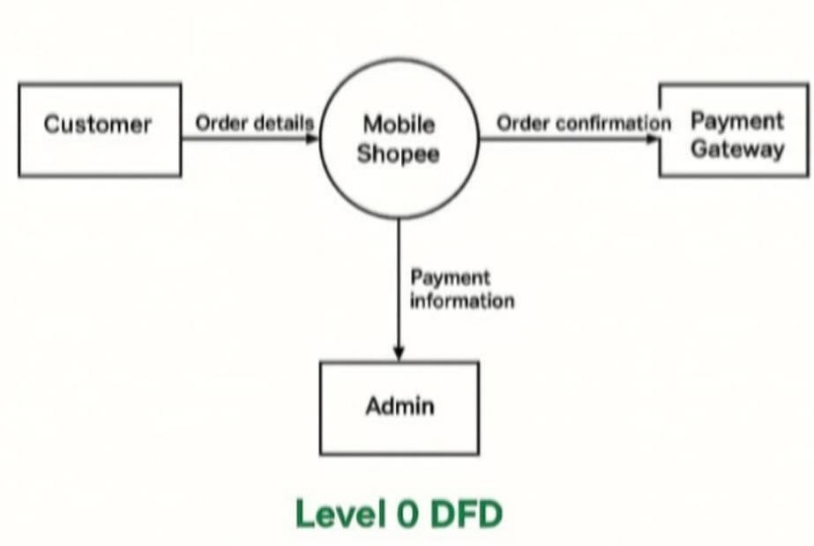

• **Process 2**: Checkout o **Customer** adds items to the cart. o **System** calculates totals and processes payment. o **System** updates the database with order details and notifies the customer.

This detailed DFD helps in better understanding the system’s internal data handling and process flow.

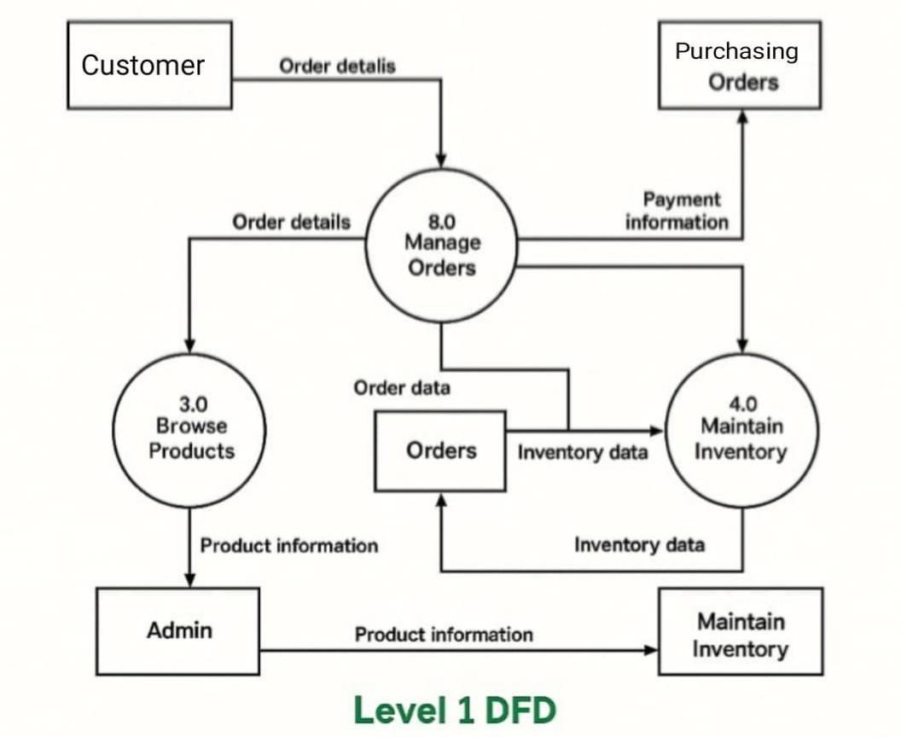

Figure: 6.3.1 Level 1 DFD

## CHAPTER 7

## TESTING

### 7.1 Testing

#### Introduction

Testing is a critical phase in the software development life cycle that ensures the developed system is free of defects, functions as expected and meets user requirements. For the **Mega bazaar Website**, testing was conducted at various levels to validate functionality, performance, and usability before deployment. Effective testing improves software quality and ensures customer satisfaction.

#### Objective

The main objectives of testing in this project were:

* To verify that all features (like product browsing, cart management, and order placement) work as intended.
* To detect and fix bugs or logical errors.
* To ensure that the system performs reliably across different devices and browsers.
* To confirm that both user-side and admin-side functionalities are secure and stable.

### 7.2 Types of Testing

Different types of testing were carried out during the development of the Megabazaar Website:

#### Unit

Individual modules such as login, product display, cart, and checkout functionalities were tested in isolation to ensure correct behaviour.

#### Integration

After unit testing, the interaction between modules (e.g., login → add to cart → checkout) was tested to check for smooth data flow and interconnectivity.

#### System

The entire system was tested as a whole to ensure it met all functional requirements and user expectations.

#### UAT

The system was reviewed by sample users to validate that the interface was userfriendly, and the workflow (searching, adding to cart, checking out) met typical customer expectations.

#### Cross-Browser

The website was tested across different web browsers (Chrome, Firefox, Safari) to ensure consistent layout and functionality.

#### Responsive

The website's layout and behaviour were tested on different screen sizes (desktop, tablet, mobile) to ensure responsive design.

### 7.3 Testing Strategy

A structured testing strategy was followed to ensure thorough validation of the system:

* **Planning:**

A testing plan was created early in the development phase to define the scope, approach, and resources needed for testing.

* **Design**:

Specific test cases were designed for key functionalities like login, cart operations, admin product management, and order confirmation. Each test case had defined input, expected output, and result status (pass/fail).

#### Manual

Since the project was small to medium scale, manual testing was conducted. Each feature was tested step-by-step using predefined test cases.

#### Bug

Any bugs or unexpected behaviour encountered during testing were recorded and fixed. Retesting was done after corrections to ensure stability.

#### Final

After all testing was completed, a final walkthrough of the website was performed to verify the completeness and readiness of the product for deployment.

## CHAPTER 8

## IMPLEMENTATION

### 8.1 Software Used

The development and deployment of the Megabazaar Website required several software tools to ensure smooth functioning and user-friendly design. The following software was used:

|  |  |
| --- | --- |
| **Purpose** | **Software / Tools** |
| UI Development | **HTML5, CSS3, JavaScript** |
| Framework/Library | **React.js** or **Vue.js** |
| Styling Framework | **Tailwind CSS** / **Bootstrap** |
| HTTP Requests | **Axios** / **Fetch API** |
| Package Manager | **npm** |
| Code Editor | **VS Code** |

### 8.2 Hardware Specification

The hardware setup used for developing and testing the project included:

|  |  |
| --- | --- |
| **Component** | **Specification** |
| Processor | Intel Core i3 or above |
| RAM | Minimum 4 GB |
| Hard Disk | 10 GB free space |
| Display | 15.6” Monitor, 1366x768 resolution or higher |
| Input Devices | Keyboard and Mouse |

Internet Connectivity Required for updates, testing, and deployment

### 8.3 Platform

The platform used for developing and running the Megabazaar Website includes:

• 🧱 **1. Application Platform (User-Facing)**

#### • 🌐 Web Platform

* **Technologies**: React.js / Vue.js / Angular for frontend
* **Access**: Via browsers (Chrome, Firefox, Safari, etc.)
* **Purpose**: For customers to browse, search, buy, and track products

#### • 📱 Mobile Platform

* **Native Apps**: Built using **React Native** / **Flutter** or native Android (Java/Kotlin) and iOS (Swift)
* **Progressive Web App (PWA)**: Provides an app-like experience through mobile browsers • **Purpose**: On-the-go shopping, push notifications, mobile payments

### 8.4 Technologies Used

#### 1. HTML5 (Hypertext Markup Language)

* Used for structuring the content of web pages.
* Provides semantic tags like <header>, <footer>, <section>, which enhance SEO and accessibility.

#### 2. CSS3 (Cascading Style Sheets

* Used for styling web pages—fonts, colours, layouts, animations.
* Supports responsive design using media queries to make the website mobile-friendly.

#### 3. JavaScript (ES6+)

* Enables dynamic and interactive elements like sliders, popups, filters, and validations.
* ES6+ features such as arrow functions, promises, and classes improve code efficiency and readability.

#### 4. Frameworks and Libraries a. React.js (Most Common in Modern E-Commerce Platforms)

* A component-based library for building fast and interactive UIs.
* Offers features like virtual DOM, reusable components, and one-way data binding.
* Often used with React Router for single-page application (SPA) behavior. **b. Vue.js**
* Lightweight and easy-to-integrate framework.
* Suitable for modular and flexible frontend development.

#### c. Angular

* A full-fledged framework by Google.
* Includes built-in modules for form handling, HTTP requests, routing, and more.

#### 5. Bootstrap / Tailwind CSS

* **Bootstrap**: Pre-designed responsive components (buttons, cards, modals).
* **Tailwind CSS**: Utility-first CSS framework for custom design without writing much custom CSS.

#### 6. TypeScript

* Superset of JavaScript that adds static typing.
* Improves code maintainability and reduces bugs—especially useful for large-scale apps like Mega Bazaar.

👨‍💻 **Tools & Environment**

* **Version Control**: Git + GitHub/GitLab

#### • Code Editor: VS Code

* **Design Prototypes**: Figma / Adobe XD
* **Testing**: Jest, React Testing Library, Cypress (for end-to-end)

**CHAPTER 9**

# SNAPSHOT

## 9.1 Snapshots

This chapter provides visual representations of the key forms and interfaces used in the **Megabazaar Website**. These snapshots help illustrate the layout, design, and functionality of the system from both admin and customer perspectives.

## 9.2 Form Design

The forms were designed with simplicity and user-friendliness in mind. Each interface is structured to allow smooth navigation, accessibility, and a responsive layout for mobile and desktop platforms.

## 9.3 Cart Page

The **Cart Page** allows users to review items they have added to their shopping cart before proceeding to checkout. It displays product names, quantities, individual prices, total price, and options to update quantities or remove items. This page ensures that users have control over their purchase selections and can make adjustments easily before finalizing the order.

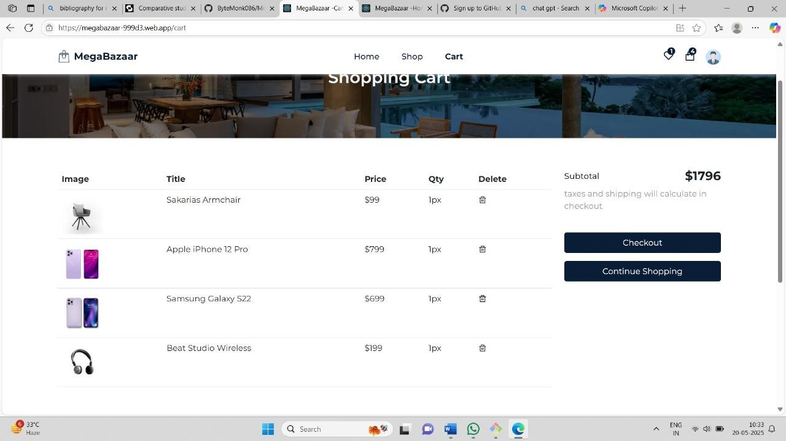 ..

Figure: 9.1.1 Cart Page

### Product Adding Page

The **Product Adding Page** is typically part of the admin or seller interface. It enables authorized users to add new products to the website by entering details such as product name, description, category, price, stock quantity, and uploading product images. This form ensures the product catalog stays updated and helps maintain a diverse and fresh product offering for customers.

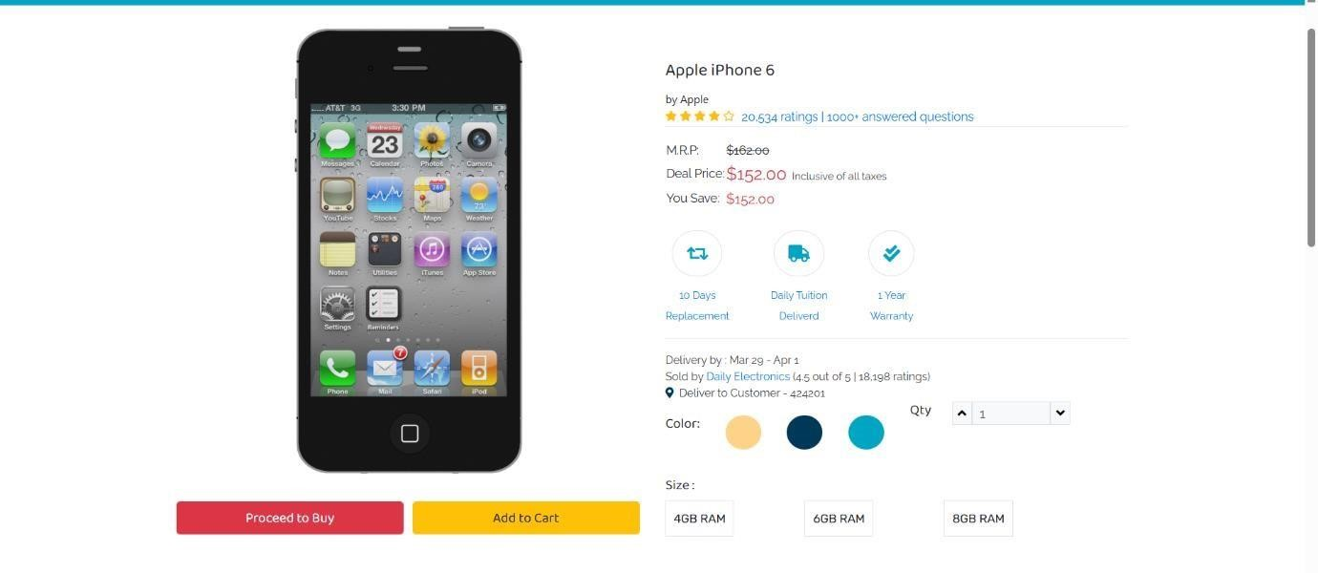

Figure: 9.1.2 Product Adding Page

### Home Page

The home page displays:

* Featured products and latest deals.
* Navigation bar with links to all key pages (Home, Categories, Cart, Login/Register).
* Search bar for quick product lookup.
* A responsive grid layout for product listings.

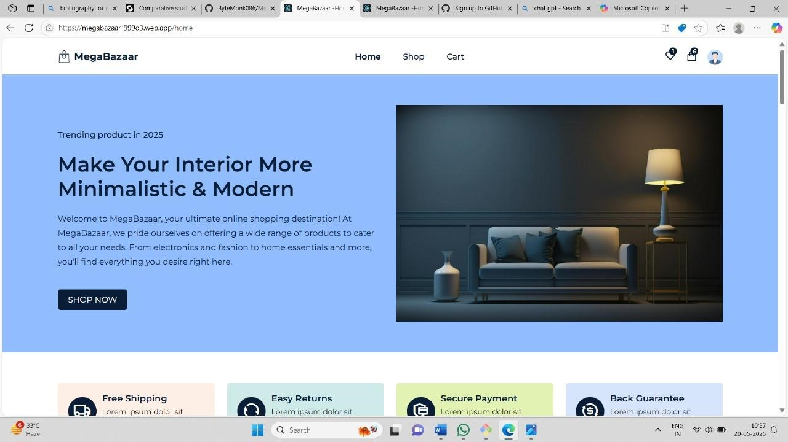

Figure: 9.1.3 Home Page

### About Us Page

This page provides information about the purpose and vision of the Mobile Shopee Website. It includes:

* Brief company overview.
* Mission and values.
* Contact information.

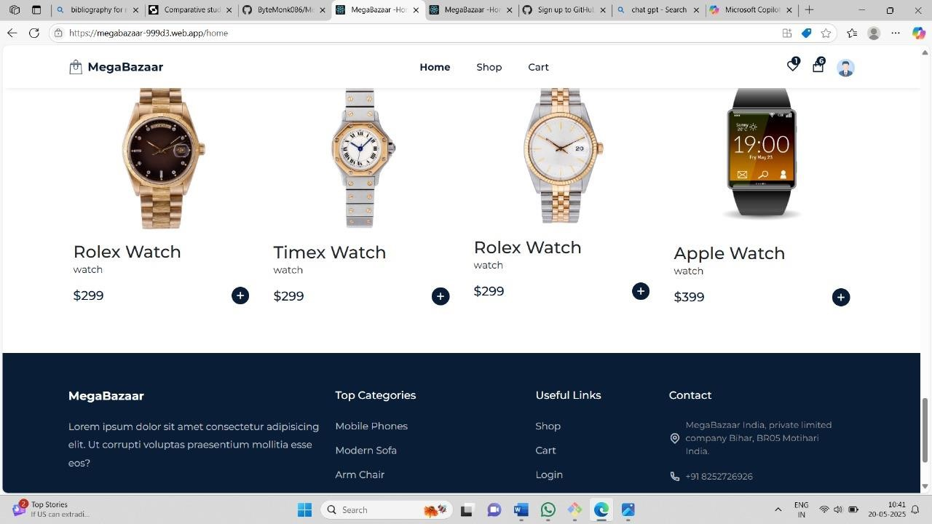

Figure: 9.1.4 About Us Page

# CHAPTER 10 MAINTENANCE

## 10.1 Software Maintenance

Software maintenance refers to the process of modifying and updating software after its initial deployment to correct faults, improve performance, or adapt it to a changing environment. For the **Megabazaar Website**, maintenance ensures that the system continues to function correctly as user needs evolve, and that it remains secure and compatible with new technologies.

### Software Maintenance Process

The software maintenance process involves several key stages:

1. **Problem Identification**: Identifying bugs or enhancement needs based on user feedback or monitoring tools.
2. **Analysis**: Evaluating the impact of the required changes on the existing system.
3. **Design**: Creating updated modules or system components.
4. **Implementation**: Making necessary changes to the code or database. 5. **Testing**: Validating that the changes don’t affect other functionalities.

6. **Deployment**: Releasing the updates to the live environment.

### Maintenance Activities

Maintenance for the Megabazaar Website is broadly categorized into four types:

* **Corrective Maintenance**: Fixing bugs or errors reported by users (e.g., login issues, cart glitches).
* **Adaptive Maintenance**: Updating the website to remain compatible with changes in browsers, devices, or third-party tools.
* **Perfective Maintenance**: Enhancing UI/UX, adding minor features, or improving performance based on user suggestions.
* **Preventive Maintenance**: Code refactoring, database optimization, and security upgrades to prevent future issues.

### Difficulties of Maintenance

While maintenance is essential, it also comes with several challenges:

* **Understanding Legacy Code**: Developers must understand the existing codebase, which can be time-consuming if not well-documented.
* **Unexpected Side Effects**: Changes in one part of the code can unintentionally affect other modules.
* **Cost and Time**: Regular updates and testing require resources and ongoing effort.
* **Security Updates**: Ensuring the system remains secure as cyber threats evolve.
* **User Dependency**: Some updates might affect users' workflow, requiring communication or training.

## CHAPTER 11

## CONCLUSION

### 11.1 Conclusion

**Mega Bazaar** has emerged as a powerful and versatile platform in the modern retail and e-commerce landscape. In an age where consumer preferences are driven by convenience, accessibility, and product variety, **MegaBazaar** fulfils all these expectations by offering a comprehensive solution that brings together buyers, sellers, and service providers under one unified system.

At its core, MegaBazaar is designed to function as a one-stop destination for shopping across various categories—ranging from fashion and electronics to personal care and home essentials. The platform not only enhances the shopping experience for customers by providing intuitive navigation, advanced search and filtering options, and secure payment mechanisms, but it also empowers small and medium businesses to expand their reach and grow in a competitive marketplace.

From a technological perspective, MegaBazaar's system design incorporates essential modules such as user management, product cataloging, inventory control, order processing, and real-time tracking. By leveraging robust backend architecture, scalable databases, cloud storage, and modern front-end frameworks, the platform ensures reliability, performance, and security. The inclusion of features such as a seller dashboard, personalized recommendations, and admin analytics further boosts operational efficiency and business intelligence.

#### Bibliography

1. [https://www.w3schools.com](https://www.w3schools.com/)
2. [https://developer.mozilla.org](https://developer.mozilla.org/)
3. <https://www.php.net/manual/en/>
4. <https://dev.mysql.com/doc/>
5. [https://www.geeksforgeeks.org](https://www.geeksforgeeks.org/)